Hey with Zion School – A Brief History
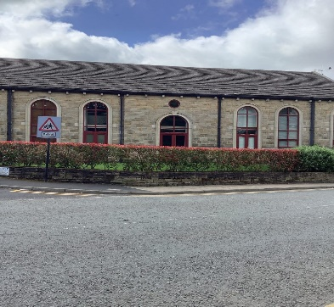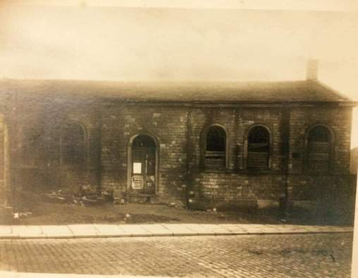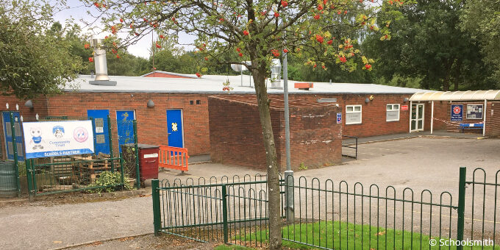
This new building (apartments) was sympathetically rebuilt and stands on the site of Hey with Zion Primary School
the original St Johns Hey School.

Hey with Zion VC Primary School was originally two separate church schools – Hey St John, Church of England School and Zion Methodist Church School. In 1978, the two schools merged and became Hey with Zion VC Primary School. Over the years, the building has been extended and changed internally to become the school we have today, which can accommodate over 300 children.

The original St Johns Hey School was built in 1839; 130 boys and girls attended during the week and 270 children attended the Sunday school. In 1885, the school was replaced with a larger school further up Stamford Road, where St Johns court is now built. Part of the original school wall still remains, as does the gatepost. The original school, which is on the opposite corner to The Grapes, became a storeroom for Rhodes Mill before becoming a storeroom for newsprint during WW2. Later, the local Owen Brothers family bought it and in the 2000s it was sympathetically rebuilt and made into apartments. The shape and the distinctive arch shape windows are a replica of the original building.

Zion Methodist School was a smaller school and was part of Zion Methodist Church. It was housed upstairs in the back of the building. The 80 or so children that attended there were taught in three classes, one infant and two juniors; each made up of more than one age group. The school had a Head Teacher and three members of staff. The new Zion Methodist Church was built to replace the old church and school.

When the new Hey with Zion School opened in 1978, it was a vastly smaller building than it is now. It was open-plan and had no separate classrooms. The children were taught in one continuous arch of space from Infant 1 through to Junior 4 (now Reception to Year 6). The ‘classes’ merged into each other with one exception – a class was squeezed onto the mezzanine, a very cramped space with a steep sloping ceiling. Outside of the building, there was no perimeter fence and in fact, a public right of way ran diagonally across the school field. The first headteacher at the new school was Mrs. Charnock. Our current headteacher, Mr Clowes has been at Hey with Zion since 1990 and has seen many changes during this time.
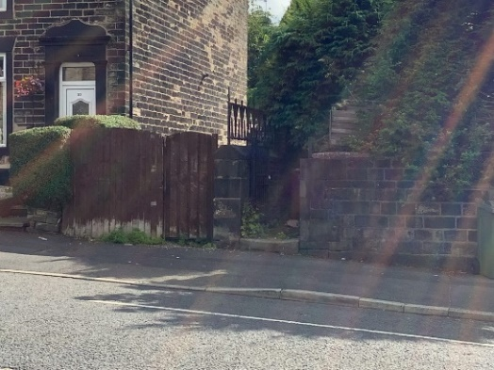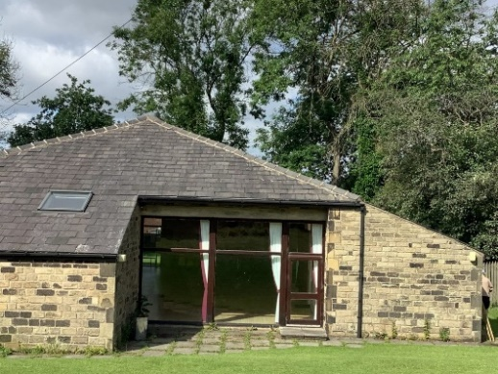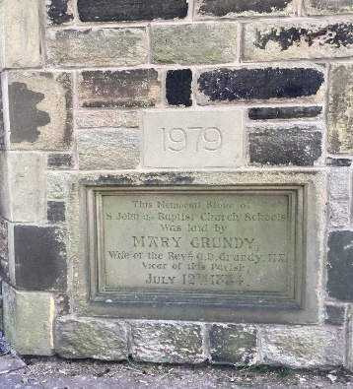
Part of the old school wall still remains. The church hall at St Johns Church was built using the stone from the demolished old
school.

