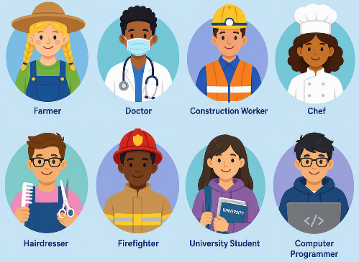
Careers Education Progression Map

Phase | Careers Focus | Pupils will... | School will provide... | Planned activities
Early Years Foundation Stage (Nursery & Reception)  Discovery – "Who helps us and what can we be?" | Build early awareness of the world of work through play and exploration.  🌟 Aspiration begins through curiosity and imagination | - Talk about familiar people and their roles (C&L, UTW).  - Recognise their own interests, strengths and preferences (PSED).  - Use imaginative play to explore different roles and occupations (EAD).  - Show curiosity about the world and ask questions about jobs and people (UTW).  - Develop confidence, independence and resilience when trying new activities (PSED & PD). | - A rich, play-based environment with role play areas linked to different occupations.  - Stories and resources that reflect a diverse range of jobs and challenge stereotypes.  - Opportunities for visitors (e.g. parents, community roles).  - Planned activities and discussions linked to the 7 areas of learning, developing communication, curiosity and understanding of the world.
Key Stage 1 (Years 1–2)  Awareness – "People who help and inspire us." | Introduce the world of work and challenge stereotypes.  🌟 Aspiration grows as pupils begin to see possibilities | - Recognise that adults have different jobs and roles.  Talk about jobs within school and the local community.  - Begin to understand that everyone has talents and strengths.  - Challenge simple stereotypes about who can do different jobs.  - Talk about what they enjoy and what they are good at. | - Careers linked to curriculum themes.  - Inclusive opportunities for all children to participate.  - Visitors from the local community.  - Opportunities to meet adults with different jobs.  - Celebrate aspirations through stories, role play and assemblies
Lower Key Stage 2 (Years 3–4)  Exploration – "Learning opens doors." | Develop understanding of skills, pathways and the wider world of work.  🌟 Aspiration develops through understanding pathways | - Explain how school subjects link to different careers.  - Recognise the importance of teamwork, resilience and problem solving.  - Explore a wider range of careers beyond their local area.  - Begin to understand that people develop skills throughout life.  - Reflect on their own interests and strengths. | - Curriculum-linked employer encounters.  - Inclusive opportunities for all children to participate.  - Visits to workplaces and community organisations.  - Enterprise and teamwork projects.  - Careers Week linked to curriculum learning.
Upper Key Stage 2 (Years 5–6)  Aspiration – "My future starts now." | Raise aspirations and prepare pupils for transition to secondary school.  🌟 Aspiration is explicit, ambitious and personal | - Understand different education and career pathways.  - Appreciate that careers change and develop over time.  - Recognise the importance of qualifications, skills and lifelong learning.  - Set personal aspirations and goals.  - Understand how their learning today prepares them for future opportunities. | - Employer talks linked to curriculum.  - University, college or workplace visits.  - Enterprise challenges.  - Transition activities linked to future aspirations.  - Careers linked explicitly to curriculum subjects.  - Inclusive opportunities for all children to participate.

Wider opportunities to find out about careers:
Visits, trips and visitors into school provide valuable real-life opportunities for children to explore the world of work in a meaningful and engaging way. By speaking directly to adults in different roles, pupils can begin to make connections between their learning, the skills they are developing, and future career possibilities. Asking simple, purposeful questions helps children to understand what different jobs involve, the skills and qualities needed, and the pathways people take. These conversations can help raise aspirations, challenge stereotypes and encourage children to think more broadly about their own potential.
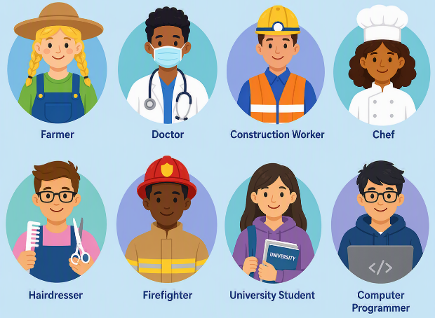
These questions can be used as a short, simple questionnaire for pupils to complete during or after trips and visits, helping to structure their conversations and capture what they have learned about different careers. The responses can be recorded in class floor books and referred to.

Key Questions for Pupils to Ask
• What does your job involve day to day, and what do you enjoy most about it?
• What skills or personal qualities are most important for doing your job well?
• What did you have to learn or what qualifications did you need to do this job?
• What advice would you give to someone our age who might be interested in a job like yours?

