Mathematics Policy
Hey with Zion

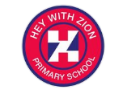



Written by | Susan Soanes
Agreed | Spring 2025
Next Review | Spring 2027
Approved by Governors | Spring 2025

Mission Statement
Hey with Zion Church of England and Methodist Primary School strives to provide a caring environment in which every individual can achieve their potential. To achieve this we wish to create a happy, secure and purposeful culture throughout the school, which is conducive to learning and high standards and is based on Christian values.

Our Vision
Hey with Zion’s Vision Statement
Jesus said, “ I have come that they may have life, and have it to the full.” John 10 verse 10
Within the love of God, we aspire to do the best we can for ourselves and others.
MATHEMATICS POLICY -
Introduction
This policy outlines what we are aiming to achieve in respect of pupils’ mathematical education at Hey with Zion Primary School. The school’s policy for mathematics is based on the National Curriculum 2014 framework and the Teaching Mathematics in Primary Schools Guidance (NCETM) July 2020. It also describes our agreed approach to the planning, delivery and assessment of the mathematics’ curriculum. The mathematics taught and the methods used reflect the recommendations outlined in both the 2014 DfE guidance and Teaching Mathematics in Primary Schools July 2020.

Aims
We aim for all pupils to:
▪ Become fluent in the fundamentals of mathematics, including through varied and frequent practice with increasingly complex problems over time, so that pupils develop conceptual understanding and the ability to recall and apply knowledge rapidly and accurately.
▪ Reason mathematically by following a line of enquiry, conjecturing relationships and generalisations, and developing an argument, justification or proof using mathematical language.
▪ Solve problems by applying their mathematics to a variety of routine and nonroutine problems, including breaking down problems into a series of simpler steps and persevering in seeking solutions.
Our Philosophy
‘Mastering mathematics means pupils acquiring a deep, long-term, secure and adaptable understanding of the subject. The phrase ‘teaching for mastery’ describes the elements of classroom practice and school organisation that combine to give pupils the best chances of mastering Mathematics. Achieving mastery means acquiring a solid enough understanding of the Mathematics taught, to enable pupils to move on to more advanced material.’ (NCETM)
At Hey with Zion, our Mathematics lessons are designed in relatively small carefully sequenced steps, which must be mastered before pupils move to the next stage. To achieve this, we recognise that pupils follow age related curriculum and that pupils develop a ‘Keep Up’ attitude with their peers (with exception to those with an EHCP: see SEND). Teachers’ keep Maths Mastery at the heart of all their lessons ensuring CPA (Concrete – Pictorial – Abstract) is used along with Stem Sentences and key mathematical language. Children are taught to discuss mathematics using mathematical sentences and correct mathematical language. We are developing a ‘We Can!’ attitude towards mathematics.
Planning, teaching and learning
At Hey with Zion we teach for conceptual understanding and follow the Concrete – Pictorial-Abstract style of teaching to ensure children have a true understanding of a concept. In Years 1 – 6 and EYFS we have developed our curriculum following the White Rose scheme to allow learners to achieve a secure and deep understanding of each mathematical concept.

Through the use of ‘White Rose Maths’ teachers ensure that knowledge, reasoning and problem solving are incorporated in all weekly planning. We ensure that fluency and reasoning are at the core of every lesson. Lesson planning ensures that the needs of all learners are met within every lesson and that all children are appropriately challenged.
In Early Years, the EYFS Framework is followed, and there is the opportunity to ‘explore maths’ and develop their understanding of mathematical concepts through taught daily maths lessons, structured activities and through play.
CPA Approach to teaching Mathematics at Hey with Zion Primary School
The CPA approach builds on children’s existing knowledge by introducing abstract concepts in a concrete and tangible way. It involves moving from concrete materials, to pictorial representations, to abstract symbols and problems.
Concrete step of CPA
Concrete is the “doing” stage. During this stage, students use concrete objects to model problems. Unlike traditional maths teaching methods where teachers demonstrate how to solve a problem, the CPA approach brings concepts to life by allowing children to experience and handle physical (concrete) objects. With the CPA framework, every abstract concept is first introduced using physical, interactive concrete materials.
For example, if a problem involves adding pieces of fruit, children can first handle actual fruit. From there, they can progress to handling manipulatives which represent the fruit.
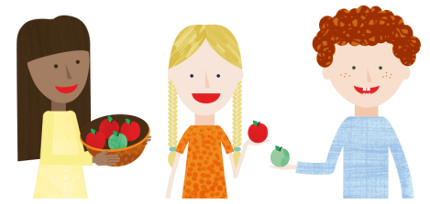

Pictorial step of CPA
Pictorial is the “seeing” stage. Here, visual representations of concrete objects are used to model problems. This stage encourages children to make a mental connection between the physical object they just handled and the abstract pictures, diagrams or models that represent the objects from the problem.
Building or drawing a model makes it easier for children to grasp difficult abstract concepts (for example, fractions). Simply put, it helps students visualise abstract problems and make them more accessible.
Abstract step of CPA
Abstract is the “symbolic” stage, where children use abstract symbols to model problems. Students will not progress to this stage until they have demonstrated that they have a solid understanding of the concrete and pictorial stages of the problem. The abstract stage involves the teacher introducing abstract concepts (for example, mathematical symbols). Children are introduced to the concept at a symbolic level, using only numbers, notation, and mathematical symbols (for example, +, –, x, /) to indicate addition, multiplication or division.
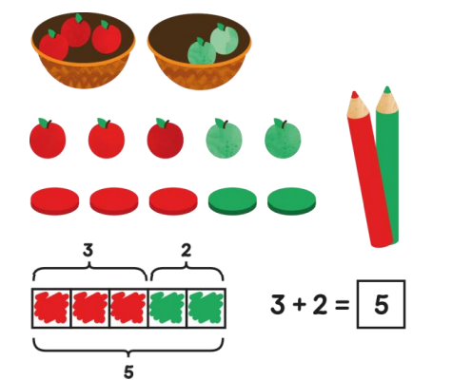

Fluency
We believe that a secure, fluent knowledge of number facts: addition, subtraction, multiplication and division is fundamental to success in Mathematics, therefore this is a high priority at Hey with Zion Primary School. We recognise the need to practice number facts daily in our maths lessons.
We encourage children to use TT Rockstars both at home and in school and this resource is used to motivate and help children to master knowledge of their times tables. Parents/carers are made aware of the number fact their child is working on so that they can support them in their learning at home. Login details are sent home.
Resources
Concrete resources and manipulatives are made available to all children to support them with their learning at Hey with Zion. In lessons we use: ten frames, place value counters, place value charts, base ten, Numicon, Cuisenaire’s, counting beads, dice, plus many other manipulatives as well as a whole school calculation policy. The use of concrete resources is determined by the lesson, concepts being taught and the child’s level of understanding of the concept.
Working walls
All classrooms have a Maths Working wall. These learning walls are current, containing key vocabulary, worked examples and other useful information to support the children with their learning during every lesson.
Assessment
During and at the end of each lesson, the class teacher makes a judgement as to whether each child has achieved the learning objective and uses this to inform future planning and intervention needs. At Hey with Zion we recognise that same-day interventions are vital to keep the class progressing together. TA’s are used to strengthen children’s understanding in class and the class teacher can plan bespoke small intervention lessons where necessary. At the end of each unit, a short assessment is carried out to enable the children to demonstrate what they have learnt and so gaps in learning are quickly identified. Termly assessments, are carried out under test conditions and the results of these are recorded.
At Hey with Zion we use ‘Boost’ to track children’s progress, and these inform our pupil progress meetings every term. All teaching staff participate in Progress Meetings where the progress of all children is discussed with the assessment coordinator and/or members of the SLT Team. Attainment and progress are discussed and analysed and compared to predictions based on prior attainment. From this, further actions are identified and future targets set for individual children.
Teaching and Learning Style
At Hey with Zion we recognize the benefits of promoting cooperative learning and to ensure all children are fully engaged in all lessons. We also promote regular times table practice using TT Rockstars.
At Hey with Zion we embrace the concept of intelligent practice, in which all children become fluent in maths through varied, frequent and thoughtful practice that deepens and embeds conceptual understanding in a logical, planned sequence.
This is what it looks like: -
• Varied methods – concrete, pictorial and abstract.
• Calculations expressed in different ways, requiring thought and understanding.
• Constructive feedback
Special educational needs and disability (SEND)
Pupils with SEND have access to a broad and balanced curriculum alongside their peers and teachers have high expectations for every pupil, whatever their prior attainment. Teachers use appropriate assessment to set targets which are deliberately ambitious and work cooperatively with our SEND Team. Lessons are planned to address potential areas of difficulty and to remove barriers to pupil achievement. In many cases, such planning leads to pupils with SEN and disabilities accessing and studying the full national curriculum.
Equal Opportunities
Within the daily Mathematics lesson teachers provide activities to support and strengthen children’s learning who find Mathematics difficult as well as providing activities to deepen and challenge high achievers in Mathematics.
Inclusion
Each child will have equal entitlement to all aspects of the maths curriculum and to experience the full range of maths activities. Therefore, care will be taken to ensure a variety of teaching and learning styles are accessed. These include varied methods – concrete, pictorial and abstract; calculations expressed in different ways, requiring thought and understanding and constructive feedback. Intervention groups will take place within maths lessons and outside: these sessions may be delivered by the teacher or teaching assistant and may involve individual or small group work.
Responses to Children’s Work
Children’s work is marked and either written or verbal feedback is given. Every lesson, time is given for children to review their previous learning and where necessary make corrections or improvements to their work.
Monitoring and Review
Monitoring of the standards of children’s work and of quality of teaching in Mathematics is the responsibility of the subject lead, the Head Teacher and the Governors. We do routine book scrutinies throughout the year and feedback to teams.

