SEND
SENDCO Janet Light
SENDCO: Lauren Kelly

Introduction
At Hey with Zion Church of England and Methodist Primary School our job is to do the best we can to enable all our children to reach their full potential. To do this, systematic steps are taken to support them through their learning journey.
This information is to inform you of the types of support available to your child at Hey with Zion Church of England and Methodist Primary School and signpost you to the Local Authority support where necessary.

How does Hey with Zion Church of England and Methodist Primary School know if my child needs extra help and what should I do if I think my child has special educational needs?
A child has a special educational need if they have a learning difficulty or disability which calls for a special educational provision to be made for them.
Children with SEND have learning difficulties and/or physical difficulties that make it harder for them to learn than most children of a similar age, and they may need extra help or support. They may have difficulty with:
- some or all of the work in school
- reading, writing or mathematics
- understanding information
- expressing themselves
- managing emotions
- understanding others
- organising themselves
- sensory perception or physical mobility
- managing their friendships or relating to adults
If a child continues to have difficulty after intervention or support, or has a high level of difficulty when they join us, they may be considered to have a special educational need or disability (SEND) and be placed on the school's SEND Register. This will be discussed with the class teacher, SENDCO and the parent/carers.
The four areas of SEND are identified in the Code of Practice as:
- Communication and interaction
- Cognition and learning
- Social, emotional and mental health difficulties
- Sensory and/or physical needs
The Special Educational Needs Code of Practice 2014 gives guidance to schools in meeting the needs of pupils. It sets out how help should be given in a step- by- step approach. As parent/carer, you will be consulted at all stages of this graduated approach (please see link below) and staff will inform you of the additional work they do with your child. The link below provides more information about the Oldham Council Graduated Response to SEND.
https://www.oldham.gov.uk/homepage/1065/graduated_response_in_schools
SEND Graduated response Toolkit
Class teachers will assess your child to identify their strengths, needs and any extra support they may require. If they need more additional support than most children their age, they may have a low-level need.

Low Level Need
This may involve:
- Extra help from a Teacher, Teaching Assistant or Higher-Level Teaching Assistant
- Small group or individual support during class time
- Additional interventions or support
- Alternative resources such as access to ICT or visual prompts
If your child continues to have difficulty even with this extra support, we may seek additional advice from other professionals and your child may then be placed at high level need.

High Level Need
These professionals may be:
- Visual or hearing impairment team

QEST (Oldham Quality Effectiveness, Support and Training Team)
- Health Professionals
- Outreach from Specialist Provision settings
- Education Psychologists (EP)
- Children's disability service. (This service provides a wide range of advice and support for children with a diagnosed disability).
- Speech and language therapy (SALT)
- Occupational Therapy (OT)
- School nurse
If your child is on the SEND register, class teachers will create a personalised 'Assess, Plan, Do, Review' document relevant to the child's needs or follow recommendations/outcomes from outside agencies.
This will be reviewed by the teacher, adults working with the child and parents on a regular basis, or as necessary, and new targets may be set or further recommendations followed.

Please see link below for Local Authority council website - Children and young people with SEND (Local Offer)
https://www.oldham.gov.uk/info/200368/children_and_young_people_with_special_educational_needs_and_disabilities

Support
Who will support my child at Hey with Zion Church of England and Methodist Primary School?
We have an experienced team of staff who are passionate about being inclusive. They will be involved in supporting your child at Hey with Zion.
These include:
Your child’s Class Teacher will make sure that the tasks set for your child are appropriate and accessible. The class teacher will inform the parent/carer of any additional provision and targets.
Teaching Assistants and Higher-Level Teaching Assistants support children in class and carry out interventions.
The Special Educational Needs Coordinator (SENDCos - Janet Light/ Lauren Kelly) co-ordinates the provision of SEN throughout the school. They will ensure the school is effective in its arrangements and provision for children with SEN, attending Local Authority meetings and keeping up to date with any national changes, Ofsted guidance.
The SEND School Governor Rebecca Wilde works with the SENDCo in leading SEN throughout the school. The Governors receive a termly report from the SENDCo to keep them updated with provision in school and any updates.
Wider Outside Agencies may work with school to support children with a particular focus, for example, Occupational Therapists, Speech and Language Therapists, QEST, Outreach and Educational Psychologists.
All support, whether from a specialist agency or within school, is reviewed on a regular basis with the SENDCO, the class teacher, and/or any other adults involved. Parents/Carers will receive reports carried out by specialist services and be given updates at parent's evening and/or 'Assess, Plan, Do, Review' meetings with the class teacher, depending on what has been agreed.

Education, Health and Care Plan (EHC Plan)
Where provision and support for children exceeds £6,000 per year, an Education Health and Care Plan may be considered by the Local Authority for additional funding. An EHC Plan brings together all the professionals that work with the child and ensures that the child's needs are being met as much as possible. An EHC Plan can be applied for at any time, if school, parents and professionals feel that it will be appropriate to meet a child’s additional needs. Parent/carers may also apply via the Local Authority.
EHC Plans are reviewed annually (annual review), or sooner if required, and would normally include parents, class teacher, SENDCO, pupil and other external agencies that work with the child. More details about EHC Plans, personalised budgets and the annual review process are available on the local authority website, see link below.
The link below provides more information about Oldham Council's Educational Health Care Plan:
https://www.oldham.gov.uk/info/201095/education_send/1442/education_healthcare_plans_ehcp

Curriculum
How do we make adaptations to the curriculum and monitor pupil progress?
Adaptations to enable children to access curriculum content are planned for, by teachers, across all curriculum areas. Adaptation means that there is an appropriate level of challenge and support to match the needs of all learners. To support the children’s access to the broad curriculum, children will be supported as widely as possible to be taught inclusively in the classroom. To support them further, children may work with an adult, either 1:1 or supported within a group, or work collaboratively with peers.
Pupil progress is monitored by Class Teachers and the Senior Leadership Team regularly. We have a rigorous progress tracking system in school and use FFT Aspire and EET assessment tracking system. For pupils working significantly below age related expectations and therefore well below the National Curriculum, PIVATs will be used to enable staff to measure small, appropriate steps of progress and to support staff planning for immediate next steps for identified pupils. This is only used for a small group of pupils on roll and parents/carers are made aware of this as an assessment and target setting tool as appropriate.

Communication

How will both you and I know how my child is doing, and how will you help me support my child's learning?
We will know if a pupil will need help if concerns are raised by parents/carers, teachers, professionals or the child; limited progress is being made; or if there is a change in the pupil's social, emotional, mental health needs or progress.
You will be informed about your child's general progress and targets through the two parents' evenings and annual end of year report. You will be informed of how your child's learning is assessed and planned and what support you may be able to provide at home.
The class teacher and/or SENDCO may speak to you more regularly depending on your child’s level of need and progress.
If you are concerned about your child, please contact your child's teacher as soon as possible - you do not have to wait until a parent's evening to talk to a member of staff about your child. The class teacher will inform the SENDCO.
At Hey with Zion we understand that you have a valuable understanding of your child's needs and wishes, and we aim to involve you in every aspect of the decision making progress.

Wellbeing

What support will there be for my child's/young person's overall wellbeing?
At Hey with Zion we support every child's wellbeing on a number of different levels and in a number of different ways. All children and parents are encouraged to follow 'Our School Rules', 'Christian Values' and 'Home School Agreement'.
We have a Pastoral Manager who provides support to children with SEND where appropriate, including support for behaviour and attendance. If a child has a medical need, there are trained first aiders in Early Years, Key stage 1 and Key stage 2.
The SENDCO, Pastoral Manager and school council facilitate the pupil voice, where children have opportunities to share their views about their provision. They may do this through communication with their class teacher, teaching assistants or filling in a pupil voice sheet. There is a parent questionnaire for SEND on the school website for all parents to share their views.

Specialist Help

Are there other professionals who can support my child?
We aim to ensure that a child with special educational needs and/or disability have their needs met. We liaise with appropriate support/children’s agencies, including:
- Speech and Language Therapists (SALT) - Work both in and out of school to complete assessments and provide strategies for children with communication, speech, and language difficulties.
- Educational Psychologists (EP) - Complete assessments/observations and provides advice for home and school.
- Occupational Therapy Service (OT) - Identify areas where a child’s function, participation and independence at school, home and the community can be supported.
- Primary Outreach Service – A qualified practitioner will offer support and advice for children with specific needs.
- Secondary Schools - We work closely with the SENDCos at high schools to ensure a successful transition. This may involve information sharing, or extra visits to the high school for children with special educational needs.
- GP's/Hospital Professionals/Paediatricians/School Nurse
- Local Authority SEND Team and Early Years SEND Team

Inclusion

How will my child be included in activities outside the classroom including school trips?
At Hey with Zion we pride ourselves on our inclusive policy and ethos. All children are given the opportunity and encouraged to go on school trips and take part in all activities in and out of the classroom. Thorough risk assessments are carried out for any out of school trip or activities. Individual risk assessments can be made for children with SEND that require a more personalised approach. Parents may be asked to attend trips to support their child. The Local Authority sets out ratios for adults to children according to age groups, however if a class teacher feels additional support is required then this will be provided where possible. This may be in the form of another member of staff, a volunteer or a parent. If it is a specific child with an additional need, school will involve the parent in planning the activity or trip and attending the trip.

Access

How accessible is Hey with Zion Church of England and Methodist Primary School?
- Adaptations have been made to make school accessible for wheelchair users.
- Adjustments would be considered, and reasonable, necessary changes and accommodations would be sought to be made, on a case-by-case basis, following an application.
- School has clearly sign posted fire procedures and completes practice drills. Personal Emergency Evacuation Plans (PEEPs) are put in place for identified pupils following discussion with staff and parents.
- Regular accessibility audits take place to inform the schools accessibility plan.
- Our School Accessibility Plan and Equal Opportunities policy includes further details regarding our access arrangements for disabled pupils and how we comply with educational legislation.
- School makes every effort to support children and parents/carers whose first language is not English.

- Who can I contact for further information?
Your child’s class teacher is your first contact if you wish to discuss your child’s progress or any concerns you may have.
Alternatively, you can arrange to speak the SENDCO (Janet Light/ Lauren Kelly) or the Pastoral Manager (Barbara Clarke).
Any complaints regarding SEND can be directed to the Headteacher (Sara Machin) or Chair of Governors (Malcolm Milwain).
For information about the support the Local Authority provide, please click the links below.
Oldham Authority Local Offer
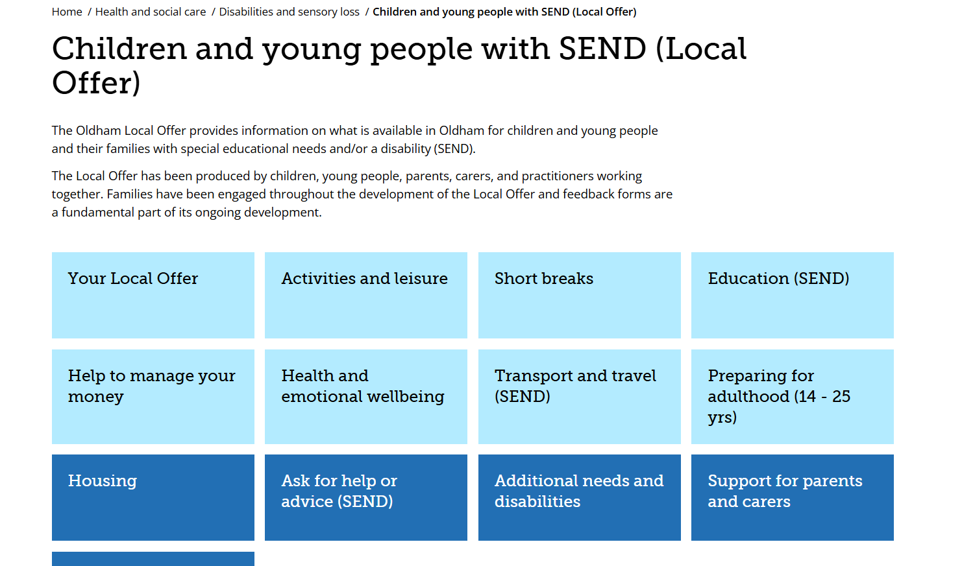
https://www.oldham.gov.uk/info/200368/children_and_young_people_with_special_educational_needs_and_disabilities
Occupational Therapy Service
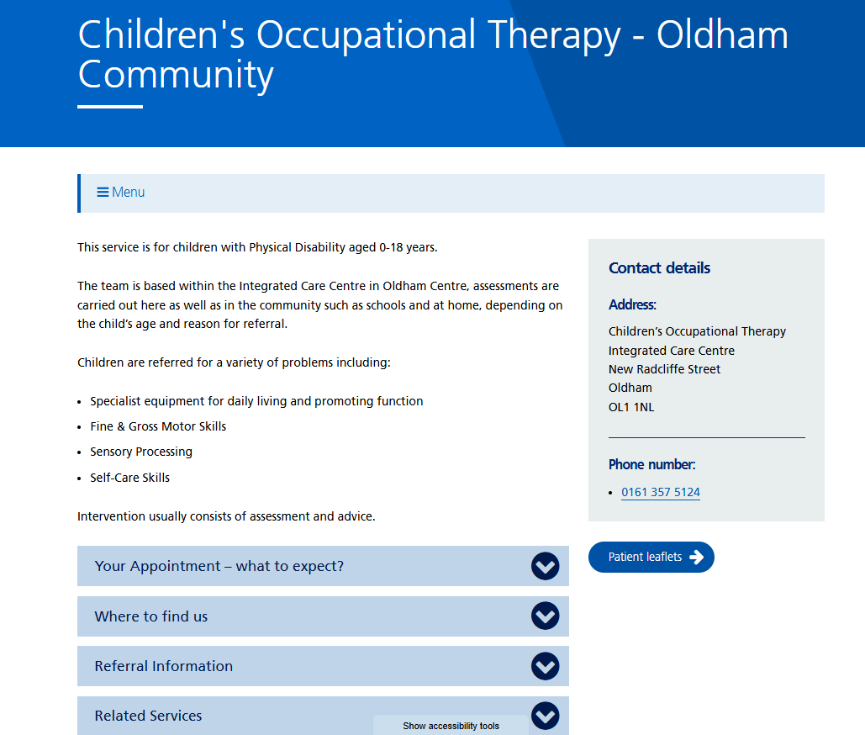
https://www.northerncarealliance.nhs.uk/our-services/childrens-occupational-therapy-1
​
Visual, hearing and speech support
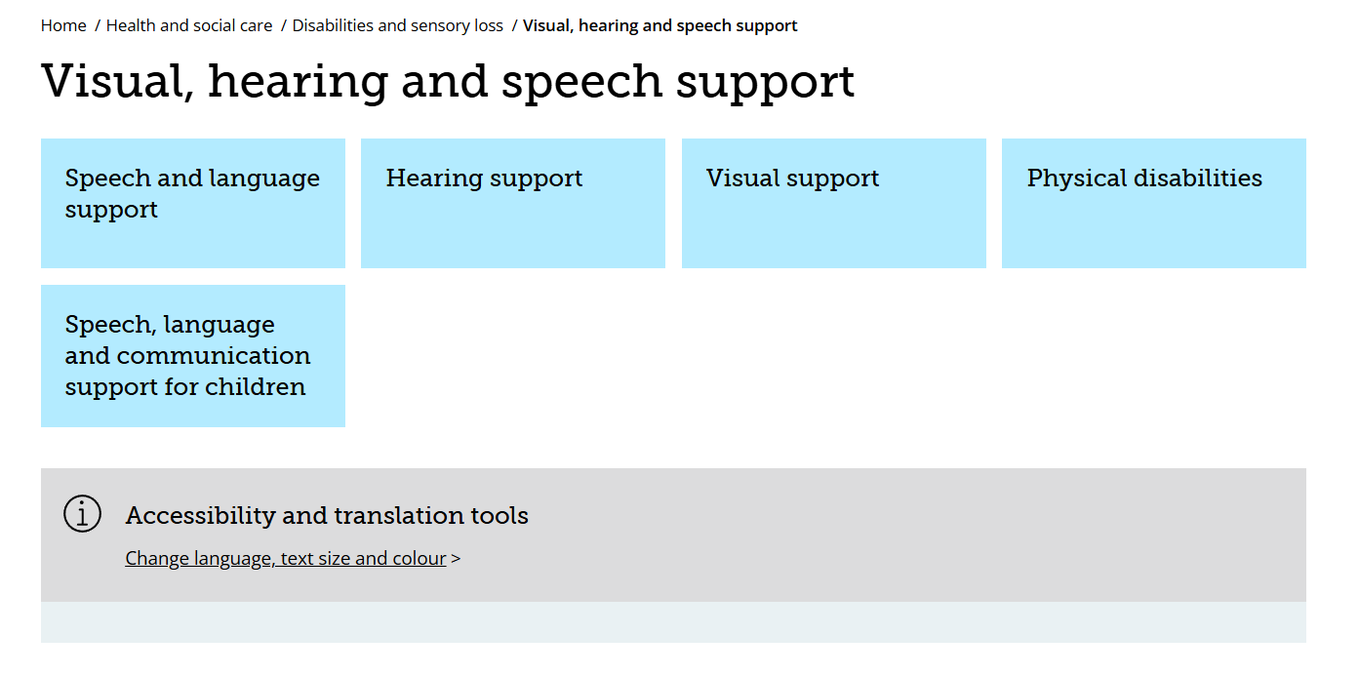
https://www.oldham.gov.uk/info/200370/sensory_impairment

Speech and Language Therapy Service
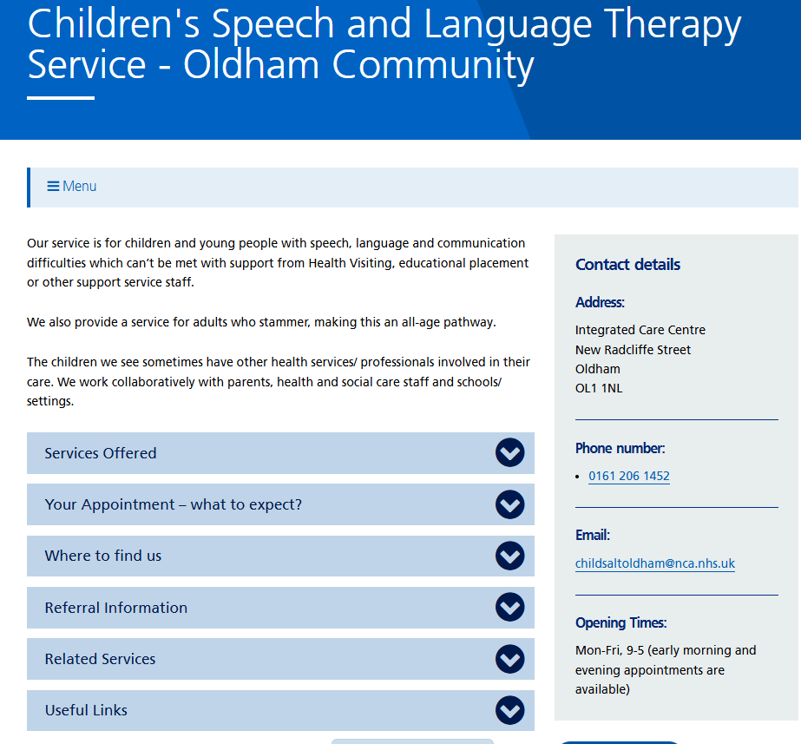
https://www.oldham.gov.uk/hsc/services/records/16/2521?send=1

Useful Contacts

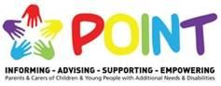

P.O.I.N.T Parents of Oldham in Touch
Oldham Parent Forum - POINT is YOUR VOICE and is where you can make sure your voice is heard in shaping the future for Children and Young People with Additional Needs and Disabilities.
http://www.pointoldham.co.uk

Hey with Zion School office – 0161 770 7620

