PE & Sports Premium
The Primary PE and Sport Premium is a government-backed funding initiative aimed at helping primary schools across England improve their physical education and sport provisions.
P.E. and school sport play a very important part in the life of Hey with Zion Primary School. We recognise the contribution of PE to the health and well-being of the children. We believe that an innovative, varied PE curriculum and extra-curricular opportunities have a positive influence on the concentration, attitude and academic achievement of all our children. Our approach to sports directly supports our key curriculum drivers of: aspiration, diversity and community.
We use the funding we receive to focus on the five key indicators as outlined by the Government and provide additional opportunities for our children to enable them to achieve well in these focus areas:
- Key indicator 1: The engagement of all pupils in regular physical activity
- Key indicator 2: The profile of PE and sport being raised across the school as a tool for whole school improvement
- Key indicator 3: Increased confidence, knowledge and skills of all staff in teaching PE and sport
- Key indicator 4: Broader experience of a range of sports and activities offered to all pupils
- Key indicator 5: Increased participation in competitive sport
At the end of 2024-25, the DfE released a new statutory digital reporting tool that schools must use to report on the spending and impact of Sport Premium. In line with the guidance, we have attached copies of our submissions to meet this requirement for July 2025.
We complete a detailed Sports Premium Analysis each year, capturing our key achievements to date and areas for future development. We link this directly to the five key indicators as detailed above. Whilst we now use the digital reporting tool, we continue to plan, record and share how we intend to use the PE and sport premium in the upcoming year in readiness for completing the tool and to ensure we plan the spend to meet the 5 key indicators. Our proposed spending plan for 2025-26 is available below.


Sports Premium Plan and Evaluation 2025-26 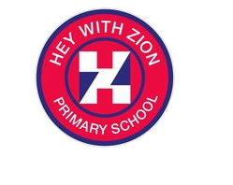
Amount of Grant Received: | TBC | Amount of Grant Spent: | TBC | Date Agreed: | July 2025 | Date to be Reviewed: | July 2026
Principles for use of PE and Sports Premium Funding:
We use the funding we receive to focus on the five key indicators as outlined by the Government and provide additional opportunities for our children to enable them to achieve well in these focus areas:
- Key indicator 1: The engagement of all pupils in regular physical activity
- Key indicator 2: The profile of PE and sport being raised across the school as a tool for whole school improvement
- Key indicator 3: Increased confidence, knowledge and skills of all staff in teaching PE and sport
- Key indicator 4: Broader experience of a range of sports and activities offered to all pupils
- Key indicator 5: Increased participation in competitive sport

We will use the Youth Sport Trust PE and Sport Premium Tracker across the year to monitor the budget and expenditure in real time across the year

Intended Plans 2025 / 26
(Against each key indicator)
 | Intent  What are your plans? | Implementation  How are you going to action and achieve them? | Impact  What impact / expected impact / sustainability are you expecting? | Expected Evidence  How will you know? What evidence do you have or expect to have?
1 | Ensure all pupils access at least 2 hours of physical activity weekly, spaced across the week to promote consistent engagement.  Increase activity at playtimes through structured zones and high-intensity equipment. | PE timetable revised to include two separate PE sessions per week on different days.  Train and deploy Play Champions and pupil Play Leaders and also Sports Champions.  Embed zoned play areas and introduce high-energy activity resources such as skipping ropes, challenge cards, bean bags, etc. | Pupils more active across the week, with improved engagement in lessons and social interactions.  Increased fitness and enthusiasm for physical activity. | Updated timetables, playtime activity rotas, photos/videos of zoned areas in use, pupil feedback, data, pupil voice surveys.
2 | Raise the profile of sport and PE to foster a culture of celebration, praise, and personal development across school. | Use assemblies, newsletters, and display boards to celebrate participation and achievements. Promote the School Games values alongside school values. Celebrate individuals weekly for sport-related effort, teamwork, and resilience. | Increased motivation, self-esteem, and recognition for pupils.  Staff and families more aware and engaged with school sport. | Photos, newsletters, assembly logs, pupil and parent feedback, display boards, School Games award documentation.
3 | Build staff confidence and skill in teaching PE, with a focus on sustainability and subject knowledge. | Use the Epworth Specialist Leader (ESL) to model lessons and support staff.  Support ECT through shared subject leadership with a phase leader.  Observe sports coaches for CPD, with a focus on dance and gymnastics. | Increased quality and consistency of PE teaching.  Staff feel more confident and capable.  Subject leads develop leadership capacity. | Staff surveys, CPD records, monitoring notes, planning scrutiny, PE Passport usage data, lesson observations.
4 | Ensure all pupils, including those who are disadvantaged or have SEND, access a wide range of sports and experiences. | Map participation by group (e.g. girls, boys, SEND, disadvantaged).  Plan termly "New Sport" focus days.  Continue use of inclusive enrichment opportunities and look at how lessons can be adapted as needed using STEPS approach | Improved engagement and enthusiasm across all pupil groups.  Children try new sports and identify personal interests and strengths. | Participation data, pupil voice, event records, enrichment timetables, photos/videos, tracking of different groups.
5 | Maintain and increase participation in competitive sport through local networks and intra-school competitions. | Engage with Oldham Games events across all levels. Plan at least four intra-school competitions across the year. Use coaches to model event delivery and upskill staff. | Pupils experience structured competition, learn teamwork and resilience.  Staff build capacity to deliver events in future. | Event logs, photos, competition results, pupil voice, School Games mark progress, coach feedback.

Review of 2025/ 26
(Against each key indicator)
 | What went well?  What impact and sustainability have you seen? | How do you know?  What evidence do you have? | What didn’t go well? | How do you know?
1
2
3
4
5

Meeting National Curriculum and Water Safety Requirements
(Year 6 2025 – 26)
1 | What percentage of your Year 6 pupils could swim competently, confidently and proficiently over a distance of at least 25 metres when they left your primary school at the end of the academic year?
2 | What percentage of your Year 6 pupils could use a range of strokes effectively [for example, front crawl, backstroke and breaststroke] when they left your primary school at the end of the academic year?
3 | What percentage of your Year 6 pupils could perform safe self-rescue in different water-based situations when they left your primary school at the end of the academic year?
4 | Schools can choose to use the Primary PE and Sport Premium to provide additional provision for swimming but this must be for activity over and above the national curriculum requirements. Have you used it in this way?

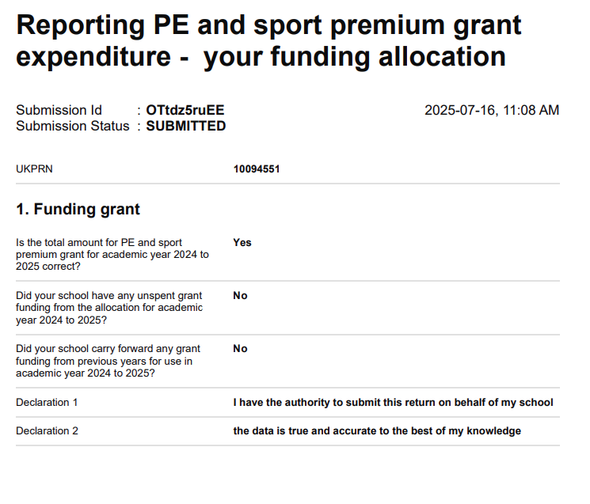

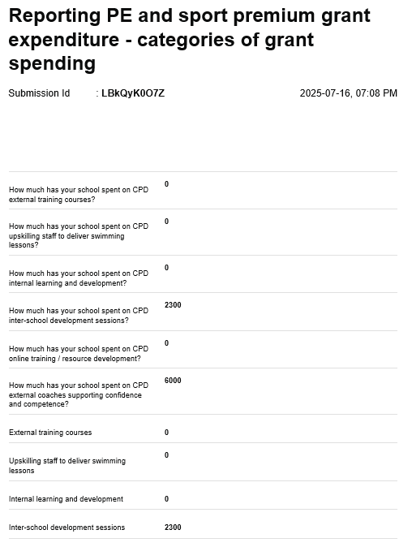

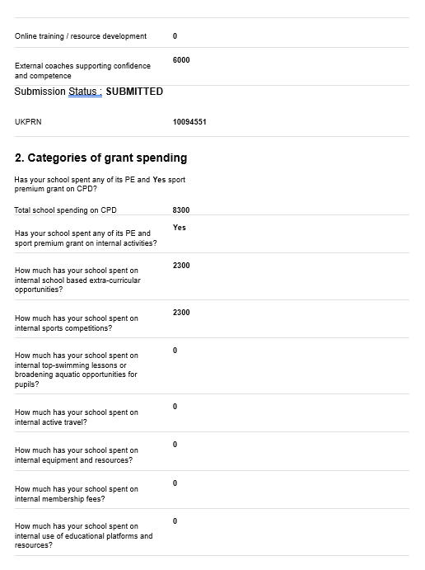

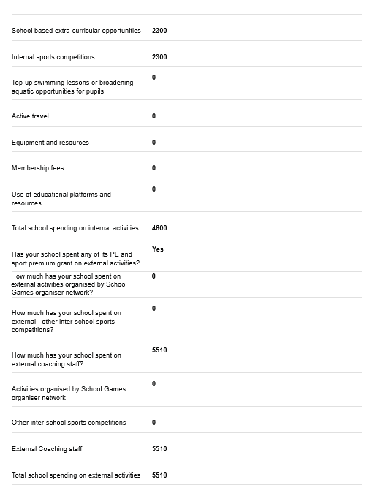

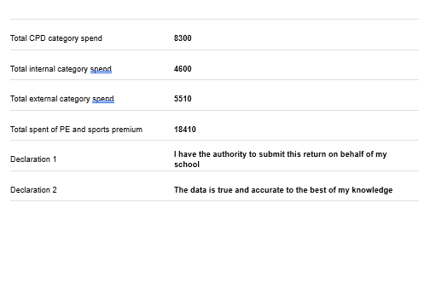

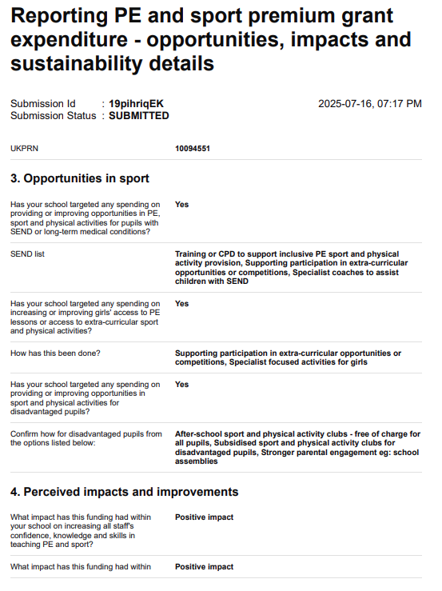

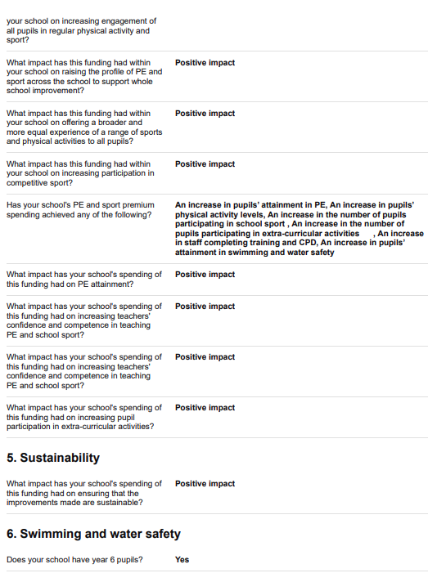

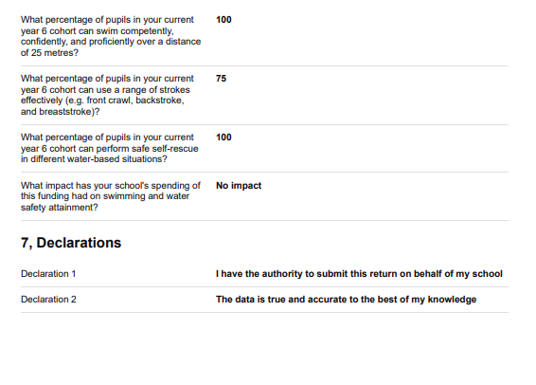

Primary Sport Premium Website Document 2024-25

The Engagement of all pupils in regular physical activity – kick starting healthy active lifestyles

Total Sports Premium funding received 2020-21: £18370

Total Sports Premium funding received 2021-22: £18230

Total sports premium funding to be received 2022-23: £18230

Total sports premium funding to be received 2023-24: £18360

Total sports premium funding to be received 2024-25: £18230

